__________________________________________________________________________________________________________________________________
For Immediate Release
__________________________________________________________________________________________________________________________________

Contact: Rebecca Aughton
Bra~vo intimates
29784 Woodward Ave
Royal Oak, MI 48073
Phone: 248.495.5648
Email: rebeccaaughton@gmail.com

Swimwear That Celebrates ALL Bodies
Amidst a sea of ill-fitting swimsuits, a beacon of bra-sized support provides a
“lift” to Metro Detroit Women.

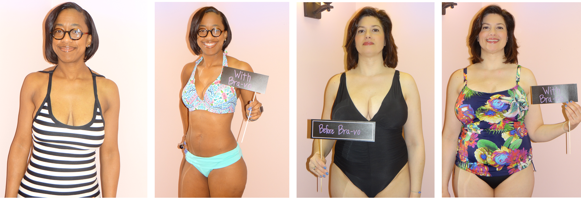

Royal Oak, MI, March 31, 2017—With the coming of warmer weather also comes two of the most feared words in the English language for women: SWIMWEAR SEASON.

A recent study revealed that the average American woman wears a 36DDD—and that’s just average! Yet most swimwear brands are still trying to fit women into what basically amounts to six sizes: XS-2X.

For many women, there’s far more at stake than just the awful dread of feeling too curvy for bikini season; there’s the very real possibility that their swimwear will turn against them and reveal too much. Regardless of her bra size, no woman dreams of “flashing” around in the pool; yet the feasibility of this kind of calamity drives many women to utter shame...even to the point where they’d rather skip out on fun summer activities altogether than risk embarrassing exposure.

It’s 2017 and we are now finally embracing women of many sizes—like the Ashley Grahams, America Ferraras, and Beyonces of the world—yet the majority of swimwear ads show painfully thin models that do not represent 99% of American women. These unacceptable images and paltry size ranges serve nothing but to undermine the average woman, and frankly, shame her for having curves, breasts, and a real body that hasn’t undergone surgery to fit some plastic, unattainable mold. It’s time for a new image! At Bra~vo intimates, we fully embrace the variety of shapes women come in by carrying supportive, bra-sized swimwear that actually fits...because it’s designed to! For most women, getting professionally fitted for swimwear, just as they would a bra, as well as seeing models that more closely resemble their own shape equates to the kind of support and confidence they need to embrace accept and love themselves for the gorgeous shape they are—not what some flimsy swimwear company tells them they should be.
The swimwear collection we carry at Bra~vo intimates includes over 90 sizes of one-piece suits, tankinis, and bikinis in numerous cuts and styles, from a D cup up to a J-cup, designed from the best brands and bra makers in the world. Like European women have known for years, these suits aren’t just stunning and on-trend, but come with built-in-support that lifts, shapes, and rounds the bust just like a bra. Our real before and after images of Bra~vo customers speak for themselves—and these role models want the women of Metro Detroit to know that real women of all sizes can look fabulous and feel confident in swimwear.

Bra~vo intimates, your Metro Detroit bra and swimwear-fitting experts, is centrally located on Woodward Avenue in Royal Oak, with appointments and walk-ins available Tuesdays – Saturdays. With fitting sessions designed specifically for swimwear, each patron has access to a 30-45 minute private swimwear fitting and consultation that includes expert bra measurements, a one-on-one fitting consultation that includes specific needs based on body type, size, lifestyle, and personal preference, and full concierge-style access to the swimwear that “suits” needs determined during consultation.

###

